20 Popular Machine Learning Metrics. Part 1: Classification & Regression Evaluation Metrics

An introduction to the most important metrics for evaluating classification, regression, ranking, vision, NLP, and deep learning models.
Note: This post has two parts. In the first part (current post), I will talk about 10 metrics that are widely used for evaluating classification and regression models. And in the second part I will talk about 10 metrics which are used to evaluate ranking, computer vision, NLP, and deep learning models.

Introduction
Choosing the right metric is crucial while evaluating machine learning (ML) models. Various metrics are proposed to evaluate ML models in different applications, and I thought it may be helpful to provide a summary of popular metrics in a here, for better understanding of each metric and the applications they can be used for. In some applications looking at a single metric may not give you the whole picture of the problem you are solving, and you may want to use a subset of the metrics discussed in this post to have a concrete evaluation of your models.
Here, I provide a summary of 20 metrics used for evaluating machine learning models. I group these metrics into different categories based on the ML model/application they are mostly used for, and cover the popular metrics used in the following problems:
- Classification Metrics (accuracy, precision, recall, F1-score, ROC, AUC, …)
- Regression Metrics (MSE, MAE)
- Ranking Metrics (MRR, DCG, NDCG)
- Statistical Metrics (Correlation)
- Computer Vision Metrics (PSNR, SSIM, IoU)
- NLP Metrics (Perplexity, BLEU score)
- Deep Learning Related Metrics (Inception score, Frechet Inception distance)
There is no need to mention that there are various other metrics used in some applications (FDR, FOR, hit@k, etc.), which I am skipping here.
As a side note, it is also worth mentioning that metric is different from loss function. Loss functions are functions that show a measure of the model performance and are used to train a machine learning model (using some kind of optimization), and are usually differentiable in model’s parameters. On the other hand, metrics are used to monitor and measure the performance of a model (during training, and test), and do not need to be differentiable. However if for some tasks the performance metric is differentiable, it can be used both as a loss function (perhaps with some regularizations added to it), and a metric, such as MSE.
Some of the metrics discussed here may be very trivial, but I decided to cover them for the sake of completeness of this post. So feel free to skip over the ones you are familiar with. Without any further due, let’s begin our journey.

Classification Related Metrics
Classification is one of the most widely used problems in machine learning with various industrial applications, from face recognition, Youtube video categorization, content moderation, medical diagnosis, to text classification, hate speech detection on Twitter.
Models such as support vector machine (SVM), logistic regression, decision trees, random forest, XGboost, convolutional neural network¹, recurrent neural network are some of the most popular classification models².
There are various ways to evaluate a classification model, and I am covering some of the most popular ones below.

1- Confusion Matrix (not a metric, but important to know!)
Let’s first make sure we know the basic terminologies used in classification problems before going through the detail of each metric. You can skip this section if you are already familiar with the terminologies.
One of the key concept in classification performance is confusion matrix (AKA error matrix), which is a tabular visualization of the model predictions versus the ground-truth labels. Each row of confusion matrix represents the instances in a predicted class and each column represents the instances in an actual class.
Let’s go through this with an example. Let’s assume we are building a binary classification to classify cat images from non-cat images. And let’s assume our test set has 1100 images (1000 non-cat images, and 100 cat images), with the below confusion matrix.
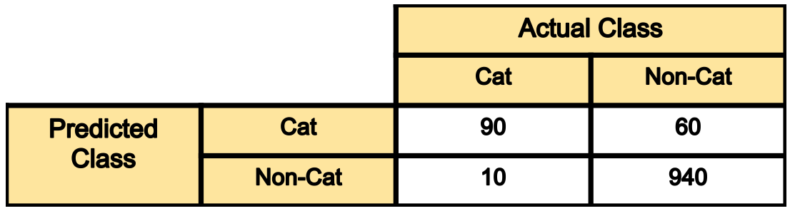
Figure 1. A sample confusion matrix
- Out of 100 cat images the model has predicted 90 of them correctly and has mis-classified 10 of them. If we refer to the “cat” class as positive and the non-cat class as negative class, then 90 samples predicted as cat are considered as as true-positive, and the 10 samples predicted as non-cat are false negative.
- Out of 1000 non-cat images, the model has classified 940 of them correctly, and mis-classified 60 of them. The 940 correctly classified samples are referred as true-negative, and those 60 are referred as false-positive.
As we can see diagonal elements of this matrix denote the correct prediction for different classes, while the off-diagonal elements denote the samples which are mis-classified.
Now that we have a better understanding of the confusion matrix, let’s get into the actual metrics.

2- Classification Accuracy
Classification accuracy is perhaps the simplest metrics one can imagine, and is defined as the number of correct predictions divided by the total number of predictions, multiplied by 100. So in the above example, out of 1100 samples 1030 are predicted correctly, resulting in a classification accuracy of:
Classification accuracy= (90+940)/(1000+100)= 1030/1100= 93.6%

3- Precision
There are many cases in which classification accuracy is not a good indicator of your model performance. One of these scenarios is when your class distribution is imbalanced (one class is more frequent than others). In this case, even if you predict all samples as the most frequent class you would get a high accuracy rate, which does not make sense at all (because your model is not learning anything, and is just predicting everything as the top class). For example in our cat vs non-cat classification above, if the model predicts all samples as non-cat, it would result in a 1000/1100= 90.9%.
Therefore we need to look at class specific performance metrics too. Precision is one of such metrics, which is defined as:
Precision= True_Positive/ (True_Positive+ False_Positive)
The precision of Cat and Non-Cat class in above example can be calculated as:
Precision_cat= #samples correctly predicted cat/#samples predicted as cat = 90/(90+60) = 60%
Precision_NonCat= 940/950= 98.9%
As we can see the model has much higher precision in predicting non-cat samples, versus cats. This is not surprising, as model has seen more examples of non-cat images during training, making it better in classifying that class.

4- Recall
Recall is another important metric, which is defined as the fraction of samples from a class which are correctly predicted by the model. More formally:
Recall= True_Positive/ (True_Positive+ False_Negative)
Therefore, for our example above, the recall rate of cat and non-cat classes can be found as:
Recall_cat= 90/100= 90%
Recall_NonCat= 940/1000= 94%

5- F1 Score
Depending on application, you may want to give higher priority to recall or precision. But there are many applications in which both recall and precision are important. Therefore, it is natural to think of a way to combine these two into a single metric. One popular metric which combines precision and recall is called F1-score, which is the harmonic mean of precision and recall defined as:
F1-score= 2*Precision*Recall/(Precision+Recall)
So for our classification example with the confusion matrix in Figure 1, the F1-score can be calculated as:
F1_cat= 2*0.6*0.9/(0.6+0.9)= 72%
The generalized version of F-score is defined as below. As we can see F1-score is special case of F_ℬ when ℬ= 1.
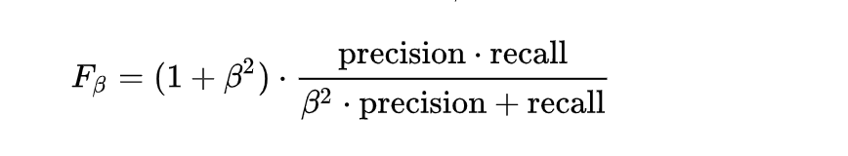
It is good to mention that there is always a trade-off between precision and recall of a model, if you want to make the precision too high, you would end up seeing a drop in the recall rate, and vice versa.

6- Sensitivity and Specificity
Sensitivity and specificity are two other popular metrics mostly used in medical and biology related fields, and are defined as:
Sensitivity= Recall= TP/(TP+FN)
Specificity= True Negative Rate= TN/(TN+FP)

7- ROC Curve
The receiver operating characteristic curve is plot which shows the performance of a binary classifier as function of its cut-off threshold. It essentially shows the true positive rate (TPR) against the false positive rate (FPR) for various threshold values. Let’s explain more.
Many of the classification models are probabilistic, i.e. they predict the probability of a sample being a cat. They then compare that output probability with some cut-off threshold and if it is larger than the threshold they predict its label as cat, otherwise as non-cat. As an example your model may predict the below probabilities for 4 sample images: [0.45, 0.6, 0.7, 0.3]. Then depending on the threshold values below, you will get different labels:
cut-off= 0.5: predicted-labels= [0,1,1,0] (default threshold)
cut-off= 0.2: predicted-labels= [1,1,1,1]
cut-off= 0.8: predicted-labels= [0,0,0,0]
As you can see by varying the threshold values, we will get completely different labels. And as you can imagine each of these scenarios would result in a different precision and recall (as well as TPR, FPR) rates.
ROC curve essentially finds out the TPR and FPR for various threshold values and plots TPR against the FPR. A sample ROC curve is shown in Figure 2.
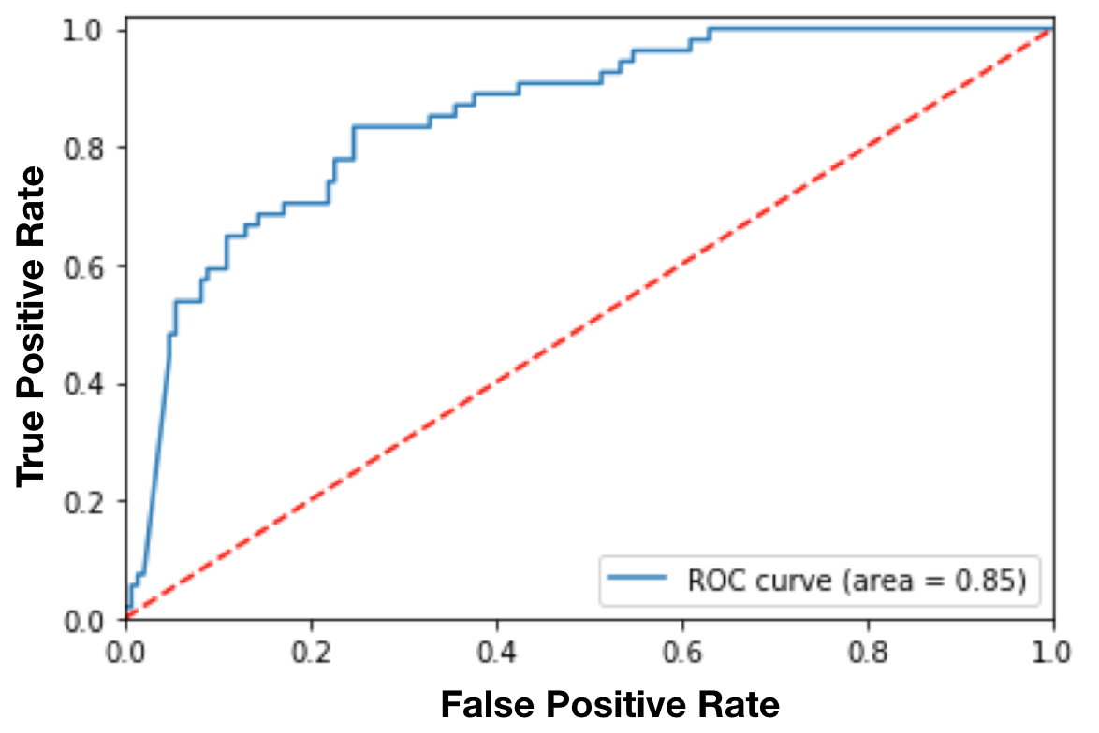
Figure 2. A sample ROC curve.
As we can see from this example, the lower the cut-off threshold on positive class, the more samples predicted as positive class, i.e. higher true positive rate (recall) and also higher false positive rate (corresponding to the right side of this curve). Therefore, there is a trade-off between how high the recall could be versus how much we want to bound the error (FPR).
ROC curve is a popular curve to look at overall model performance and pick a good cut-off threshold for the model.

8- AUC
The area under the curve (AUC), is an aggregated measure of performance of a binary classifier on all possible threshold values (and therefore it is threshold invariant).
AUC calculates the area under the ROC curve, and therefore it is between 0 and 1. One way of interpreting AUC is as the probability that the model ranks a random positive example more highly than a random negative example.
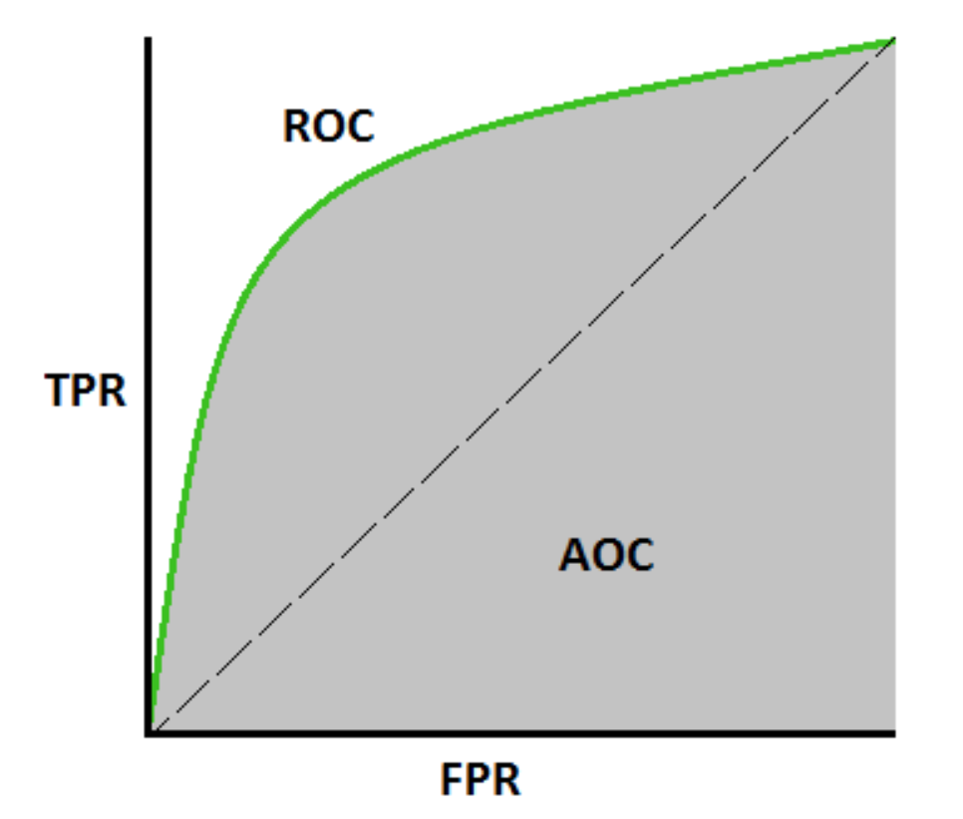
Figure 3. The gray area in this ROC curve denotes the AUC.
On high-level, the higher the AUC of a model the better it is. But sometimes threshold independent measure is not what you want, e.g. you may care about your model recall and require that to be higher than 99% (while it has a reasonable precision or FPR). In that case, you may want to tune your model threshold such that it meets your minimum requirement on those metrics (and you may not care even if you model AUC is not too high).
Therefore in order to decide how to evaluate your classification model performance, perhaps you want to have a good understanding of the business/problem requirement and the impact of low recall vs. low precision, and decide what metric to optimize for.
From a practical standpoint, a classification model which outputs probabilities is preferred over a single label output, as it provides the flexibility of tuning the threshold such that it meets your minimum recall/precision requirements. Not all models provide this nice probabilistic outputs though, e.g. SVM does not provide a simple probability as an output (although it provides margin which can be used to tune the decision, but it is not as straightforward and interpretable as having output probabilities).

Regression Related Metrics
Regression models are another family of machine learning and statistical models, which are used to predict a continuous target values³. They have a wide range of applications, from house price prediction, E-commerce pricing systems, weather forecasting, stock market prediction, to image super resolution, feature learning via auto-encoders, and image compression.
Models such as linear regression, random forest, XGboost, convolutional neural network, recurrent neural network are some of the most popular regression models.
Metrics used to evaluate these models should be able to work on a set of continuous values (with infinite cardinality), and are therefore slightly different from classification metrics.

9- MSE
“Mean squared error” is perhaps the most popular metric used for regression problems. It essentially finds the average squared error between the predicted and actual values.
Let’s assume we have a regression model which predicts the price of houses in Seattle area (show them with ŷᵢ), and let’s say for each house we also have the actual price the house was sold for (denoted with yᵢ). Then the MSE can be calculated as:

Sometimes people use RMSE to have a metric with scale as the target values, which is essentially the square root of MSE.
Looking at house pricing prediction, RMSE essentially shows what is the average deviation in your model predicted house prices from the target values (the prices the houses are sold for).

10- MAE
Mean absolute error (or mean absolute deviation) is another metric which finds the average absolute distance between the predicted and target values. MAE is define as below:

MAE is known to be more robust to the outliers than MSE. The main reason being that in MSE by squaring the errors, the outliers (which usually have higher errors than other samples) get more attention and dominance in the final error and impacting the model parameters.
It is also worth mentioning that there is a nice maximum likelihood (MLE) interpretation behind MSE and MAE metrics. If we assume a linear dependence between features and targets, then MSE and MAE correspond to the MLE on the model parameters by assuming Gaussian and Laplace priors on the model errors respectively.

Inlier Ratio Metric:
There is also another metric for evaluating regression models, called inlier ratio, which is essentially the percentage of data points which are predicted with an error less than a margin. This metric is mainly used in RANSAC⁴ model and its extensions (a family of robust estimation models).

Summary
In this post, we provided an introduction to some of the 10 popular ML metrics used for evaluating the performance of classification and regression models. In the next part of this post, we are going to provide an introduction to 10 more advanced metrics used for assessing the performance of Ranking, Statistical, Computer Vision, NLP, and Deep Learning Models.

References
[1] Ian Goodfellow, Yoshua Bengio, and Aaron Courville. “Deep learning”, MIT press, 2016.
[2] Christopher M. Bishop, “Pattern recognition and machine learning”, springer, 2006.
[3] Jerome Friedman, Trevor Hastie, and Robert Tibshirani. “The elements of statistical learning”, Springer series in statistics, 2001.
[4] Tilo Strutz, “Data fitting and uncertainty: A practical introduction to weighted least squares and beyond”, Vieweg and Teubner, 2010.

20 Popüler Makine Öğrenimi Metrikleri. Bölüm 1: Sınıflandırma ve Regresyon Değerlendirme Metrikleri

Sınıflandırma, regresyon, sıralama, vizyon, NLP ve derin öğrenme modellerini değerlendirmek için en önemli metriklere giriş.
Not: Bu gönderi iki bölümden oluşmaktadır. İlk bölümde (şimdiki yazı), sınıflandırma ve regresyon modellerini değerlendirmek için yaygın olarak kullanılan 10 metrikten bahsedeceğim. İkinci bölümde ise sıralama, bilgisayarla görme, NLP vederin öğrenme modellerini değerlendirmek için kullanılan 10 metrikten bahsedeceğim.


Tanıtım
Makine öğrenimi (ML) modellerini değerlendirirken doğru metriği seçmek çok önemlidir. ML modellerini farklı uygulamalarda değerlendirmek için çeşitli metrikler önerilmiştir ve her metriği ve kullanılabilecekleri uygulamaları daha iyi anlamak için burada popüler metriklerin bir özetini sağlamanın yardımcı olabileceğini düşündüm. Bazı uygulamalarda tek bir metriğe bakmak, çözdüğünüz sorunun bütün resmini size vermeyebilir ve modellerinizin somut bir değerlendirmesini yapmak için bu gönderide tartışılan metriklerin bir alt kümesini kullanmak isteyebilirsiniz.
Burada, makine öğrenimi modellerini değerlendirmek için kullanılan 20 ölçümün bir özetini sunuyorum . Bu metrikleri, çoğunlukla kullanıldıkları ML modeline/uygulamasına göre farklı kategorilerde gruplandırıyorum ve aşağıdaki problemlerde kullanılan popüler metrikleri ele alıyorum:
- Sınıflandırma Metrikleri (doğruluk, kesinlik, hatırlama, F1 puanı, ROC, AUC, …)
- Regresyon Metrikleri (MSE, MAE)
- Sıralama Metrikleri (MRR, DCG, NDCG)
- İstatistiksel Metrikler (Korelasyon)
- Bilgisayarla Görme Metrikleri (PSNR, SSIM, IoU)
- NLP Metrikleri (Şaşkınlık, BLEU puanı)
- Derin Öğrenme İle İlgili Metrikler (Başlangıç ​​puanı, Frechet Başlangıç ​​mesafesi)
Burada atladığım bazı uygulamalarda (FDR, FOR, hit@k, vb.) kullanılan çeşitli başka metrikler olduğunu söylemeye gerek yok.
Bir yan not olarak, metriğin kayıp fonksiyonundan farklı olduğunu da belirtmekte fayda var . Kayıp fonksiyonları, model performansının bir ölçüsünü gösteren ve bir makine öğrenimi modelini eğitmek için kullanılan (bir çeşit optimizasyon kullanarak) fonksiyonlardır ve genellikle modelin parametrelerinde türevlenebilirdir. Öte yandan, metrikler bir modelin performansını (eğitim ve test sırasında) izlemek ve ölçmek için kullanılır ve türevlenebilir olmaları gerekmez. Bununla birlikte, bazı görevler için performans metriği türevlenebilirse, hem bir kayıp işlevi (belki de buna bazı düzenlileştirmeler eklenerek) hem de MSE gibi bir metrik olarak kullanılabilir.
Burada tartışılan metriklerden bazıları çok önemsiz olabilir, ancak bu yazının eksiksiz olması adına bunları ele almaya karar verdim. Bu yüzden aşina olduklarınızı atlamaktan çekinmeyin. Daha fazla gecikmeden, hadi yolculuğumuza başlayalım.

Sınıflandırmayla İlgili Metrikler
Twitter'da yüz tanıma, Youtube video kategorizasyonu, içerik moderasyonu, tıbbi teşhis, metin sınıflandırma, nefret söylemi algılama gibi çeşitli endüstriyel uygulamalarla makine öğrenmesinde sınıflandırma en çok kullanılan problemlerden biridir.
Destek vektör makinesi (SVM), lojistik regresyon, karar ağaçları, rastgele orman, XGboost, evrişimli sinir ağı¹, tekrarlayan sinir ağı gibi modeller en popüler sınıflandırma modellerinden² bazılarıdır.
Bir sınıflandırma modelini değerlendirmenin çeşitli yolları vardır ve aşağıda en popüler olanlardan bazılarını ele alıyorum.

1- Karışıklık Matrisi (metrik değil, bilinmesi önemlidir!)
Her bir metriğin ayrıntılarını incelemeden önce, sınıflandırma problemlerinde kullanılan temel terminolojileri bildiğimizden emin olalım. Terminolojilere zaten aşina iseniz bu bölümü atlayabilirsiniz.
Sınıflandırma performansındaki anahtar kavramlardan biri , model tahminlerinin temel gerçeklik etiketlerine karşı tablo halinde görselleştirilmesi olan karışıklık matrisidir (AKA hata matrisi). Karışıklık matrisinin her satırı, tahmin edilen bir sınıftaki örnekleri temsil eder ve her sütun, gerçek bir sınıftaki örnekleri temsil eder.
Bunu bir örnekle ele alalım. Kedi görüntülerini kedi olmayan görüntülerden sınıflandırmak için ikili bir sınıflandırma oluşturduğumuzu varsayalım. Test setimizin aşağıdaki karışıklık matrisi ile 1100 görüntüye (1000 kedi olmayan görüntü ve 100 kedi görüntüsü) sahip olduğunu varsayalım.
Şekil 1. Örnek bir karışıklık matrisi
- Model, 100 kedi resminden 90 tanesini doğru tahmin etmiş ve 10 tanesini yanlış sınıflandırmıştır. “Kedi” sınıfına pozitif ve kedi olmayan sınıfa negatif sınıf olarak atıfta bulunursak, kedi olarak tahmin edilen 90 örnek doğru pozitif olarak kabul edilir ve kedi olmayan olarak tahmin edilen 10 örnek yanlış negatif olarak kabul edilir .
- Model, kedi olmayan 1000 görüntüden 940'ını doğru, 60'ını yanlış sınıflandırdı. Doğru sınıflandırılmış 940 örneğe doğru-negatif ve bu 60 örneğe yanlış-pozitif denir .
Gördüğümüz gibi bu matrisin köşegen elemanları farklı sınıflar için doğru tahmini ifade ederken, köşegen dışı elemanlar yanlış sınıflandırılan örnekleri ifade etmektedir.
Artık karışıklık matrisini daha iyi anladığımıza göre, gerçek metriklere geçelim.

2- Sınıflandırma Doğruluğu
Sınıflandırma doğruluğu, belki de hayal edilebilecek en basit metriktir ve doğru tahminlerin sayısının toplam tahmin sayısına bölünmesiyle 100 ile çarpılması olarak tanımlanır . Bu nedenle, yukarıdaki örnekte, 1100 numuneden 1030'u doğru bir şekilde tahmin edilir ve bu da aşağıdaki sınıflandırma doğruluğu ile sonuçlanır:
Sınıflandırma doğruluğu = (90+940)/(1000+100)= 1030/1100= %93,6

3- Hassasiyet
Sınıflandırma doğruluğunun model performansınızın iyi bir göstergesi olmadığı birçok durum vardır. Bu senaryolardan biri, sınıf dağılımınızın dengesiz olduğu zamandır (bir sınıf diğerlerinden daha sıktır). Bu durumda, tüm örnekleri en sık görülen sınıf olarak tahmin etseniz bile, hiçbir anlam ifade etmeyen yüksek bir doğruluk oranı elde edersiniz (çünkü modeliniz hiçbir şey öğrenmiyor ve her şeyi en üst sınıf olarak tahmin ediyor). Örneğin, yukarıdaki kedi ve kedi olmayan sınıflandırmamızda, model tüm örnekleri kedi olmayan olarak tahmin ederse, 1000/1100= %90.9 ile sonuçlanır.
Bu nedenle sınıfa özel performans ölçütlerine de bakmamız gerekiyor. Kesinlik, şu şekilde tanımlanan metriklerden biridir:
Kesinlik= True_Positive/ (True_Positive+ False_Positive)
Yukarıdaki örnekte Cat ve Non-Cat sınıfının kesinliği şu şekilde hesaplanabilir:
Precision_cat = #samples doğru tahmin edilen cat/#samples cat olarak tahmin edilen = 90/(90+60) = %60
Precision_NonCat= 940/950= %98,9
Gördüğümüz gibi, model kedilere kıyasla kedi olmayan örnekleri tahmin etmede çok daha yüksek hassasiyete sahip. Model, eğitim sırasında kedi olmayan görüntülerin daha fazla örneğini gördüğünden, bu sınıfı sınıflandırmada daha iyi olduğu için bu şaşırtıcı değil.

4- Geri Çağırma
Geri çağırma, model tarafından doğru tahmin edilen bir sınıftan örneklerin kesri olarak tanımlanan bir diğer önemli metriktir. Daha resmi:
Geri Çağırma= True_Positive/ (True_Positive+ False_Negative)
Bu nedenle, yukarıdaki örneğimiz için, kedi ve kedi olmayan sınıfların hatırlama oranı şu şekilde bulunabilir:
Geri Çağırma_cat= 90/100= %90
Recall_NonCat= 940/1000= %94

5- F1 Skoru
Uygulamaya bağlı olarak, hatırlamaya veya kesinliğe daha yüksek öncelik vermek isteyebilirsiniz. Ancak hem hatırlamanın hem de kesinliğin önemli olduğu birçok uygulama vardır. Bu nedenle, bu ikisini tek bir metrikte birleştirmenin bir yolunu düşünmek doğaldır. Kesinlik ve geri çağırmayı birleştiren popüler bir metrik, kesinlik ve hatırlamanın harmonik ortalaması olan F1-skoru olarak adlandırılır:
F1-puanı= 2*Hassas*Geri Çağırma/(Hassas+Geri Çağırma)
Dolayısıyla, Şekil 1'deki karışıklık matrisli sınıflandırma örneğimiz için F1-skoru şu şekilde hesaplanabilir:
F1_cat= 2*0.6*0.9/(0.6+0.9)= %72
F-skorunun genelleştirilmiş versiyonu aşağıdaki gibi tanımlanmıştır. Gördüğümüz gibi, F1-skoru, ℬ= 1 olduğunda F_ℬ'nin özel halidir.
Kesinlik ve bir modelin geri çağrılması arasında her zaman bir değiş tokuş olduğunu belirtmekte fayda var, hassasiyeti çok yüksek yapmak istiyorsanız, geri çağırma oranında bir düşüş göreceksiniz ve bunun tersi de geçerlidir.

6- Duyarlılık ve Özgüllük
Duyarlılık ve özgüllük, çoğunlukla tıp ve biyoloji ile ilgili alanlarda kullanılan diğer iki popüler ölçüttür ve şu şekilde tanımlanır:
Hassasiyet= Geri Çağırma= TP/(TP+FN)
Özgüllük= Gerçek Negatif Oran= TN/(TN+FP)

7- ROC Eğrisi
Alıcı işletim karakteristik eğrisi , bir ikili sınıflandırıcının performansını kesme eşiğinin fonksiyonu olarak gösteren bir grafiktir. Esasen, çeşitli eşik değerleri için yanlış pozitif orana (FPR) karşı gerçek pozitif oranı (TPR) gösterir. Daha fazlasını açıklayalım.
Sınıflandırma modellerinin çoğu olasılıklıdır, yani bir örneğin kedi olma olasılığını tahmin ederler. Daha sonra bu çıktı olasılığını bazı kesme eşikleri ile karşılaştırırlar ve eğer eşikten daha büyükse etiketini kedi olarak, aksi halde kedi olmayan olarak tahmin ederler. Örnek olarak, modeliniz 4 örnek görüntü için aşağıdaki olasılıkları tahmin edebilir: [0.45, 0.6, 0.7, 0.3] . Ardından aşağıdaki eşik değerlerine bağlı olarak farklı etiketler alacaksınız:
kesme= 0,5: tahmin edilen-etiketler= [0,1,1,0] (varsayılan eşik)
kesme= 0,2: tahmin edilen-etiketler= [1,1,1,1]
eşik= 0,8: tahmin edilen- etiketler= [0,0,0,0]
Eşik değerlerini değiştirerek görebileceğiniz gibi, tamamen farklı etiketler elde edeceğiz. Ve tahmin edebileceğiniz gibi, bu senaryoların her biri farklı bir kesinlik ve geri çağırma (ayrıca TPR, FPR) oranlarıyla sonuçlanacaktır.
ROC eğrisi temel olarak çeşitli eşik değerleri için TPR ve FPR'yi bulur ve TPR'yi FPR'ye karşı çizer. Örnek bir ROC eğrisi Şekil 2'de gösterilmektedir.
Şekil 2. Örnek bir ROC eğrisi.
Bu örnekten görebileceğimiz gibi, pozitif sınıfta kesme eşiği ne kadar düşükse, pozitif sınıf olarak tahmin edilen örnek sayısı o kadar fazladır, yani daha yüksek gerçek pozitif oran (hatırlama) ve ayrıca daha yüksek yanlış pozitif oran (bu eğrinin sağ tarafına karşılık gelir) ). Bu nedenle, geri çağırmanın ne kadar yüksek olabileceği ile hatayı ne kadar sınırlamak istediğimiz (FPR) arasında bir denge vardır.
ROC eğrisi, genel model performansına bakmak ve model için iyi bir kesme eşiği seçmek için popüler bir eğridir.

8- EAA
Eğrinin altındaki alan (AUC), bir ikili sınıflandırıcının tüm olası eşik değerleri üzerindeki performansının toplu bir ölçüsüdür (ve dolayısıyla eşik değişmezdir ) .
AUC, ROC eğrisi altındaki alanı hesaplar ve bu nedenle 0 ile 1 arasındadır. AUC'yi yorumlamanın bir yolu, modelin rastgele bir pozitif örneği rastgele bir negatif örnekten daha yüksek sıralama olasılığıdır.
Şekil 3. Bu ROC eğrisindeki gri alan AUC'yi gösterir.
Yüksek düzeyde, bir modelin AUC'si ne kadar yüksekse, o kadar iyidir. Ancak bazen eşikten bağımsız ölçüm istediğiniz şey değildir, örneğin, modelinizin geri çağrılmasını önemseyebilir ve bunun %99'dan yüksek olmasını isteyebilirsiniz (makul bir kesinlik veya FPR'ye sahipken). Bu durumda, model eşiğinizi, bu metriklerdeki minimum gereksiniminizi karşılayacak şekilde ayarlamak isteyebilirsiniz (ve AUC'yi çok yüksek modelleseniz bile umursamayabilirsiniz).
Bu nedenle, sınıflandırma modeli performansınızı nasıl değerlendireceğinize karar vermek için, belki de iş/sorun gereksinimini ve düşük geri çağırma ile düşük hassasiyetin etkisini iyi bir şekilde anlamak ve hangi metriği optimize edeceğinize karar vermek isteyebilirsiniz.
Pratik açıdan bakıldığında, minimum geri çağırma/kesinlik gereksinimlerinizi karşılayacak şekilde eşiği ayarlama esnekliği sağladığından, tek bir etiket çıktısı yerine olasılıkları çıkaran bir sınıflandırma modeli tercih edilir. Yine de tüm modeller bu güzel olasılıklı çıktıları sağlamaz, örneğin SVM bir çıktı olarak basit bir olasılık sağlamaz (kararı ayarlamak için kullanılabilecek marj sağlar, ancak çıktı olasılıklarına sahip olduğu kadar basit ve yorumlanabilir değildir).

Regresyonla İlgili Metrikler
Regresyon modelleri, sürekli bir hedef değerleri tahmin etmek için kullanılan başka bir makine öğrenimi ve istatistiksel modeller ailesidir³. Ev fiyatı tahmini, E-ticaret fiyatlandırma sistemleri, hava durumu tahmini, borsa tahmininden görüntü süper çözünürlüğüne, otomatik kodlayıcılar aracılığıyla özellik öğrenme ve görüntü sıkıştırmaya kadar geniş bir uygulama yelpazesine sahiptirler.
Doğrusal regresyon, rastgele orman, XGboost, evrişimli sinir ağı, tekrarlayan sinir ağı gibi modeller en popüler regresyon modellerinden bazılarıdır.
Bu modelleri değerlendirmek için kullanılan metrikler, bir dizi sürekli değer (sonsuz kardinalite ile) üzerinde çalışabilmelidir ve bu nedenle sınıflandırma metriklerinden biraz farklıdır.

9- MSE
“Ortalama kare hatası” belki de regresyon problemleri için kullanılan en popüler ölçümdür. Esasen, tahmin edilen ve gerçek değerler arasındaki ortalama karesel hatayı bulur.
Seattle bölgesindeki evlerin fiyatını tahmin eden bir regresyon modelimiz olduğunu varsayalım (onları ŷᵢ ile gösterin) ve diyelim ki her bir ev için aynı zamanda evin satıldığı gerçek fiyata da sahibiz (yᵢ ile gösterilir). Daha sonra MSE şu şekilde hesaplanabilir:
Bazen insanlar RMSE'yi, esasen MSE'nin karekökü olan hedef değerler olarak ölçeğe sahip bir metriğe sahip olmak için kullanırlar.
Ev fiyat tahminine bakıldığında, RMSE temel olarak modelinizin tahmini ev fiyatlarındaki hedef değerlerden (evlerin satıldığı fiyatlar) ortalama sapmasının ne olduğunu gösterir.

10- MAE
Ortalama mutlak hata (veya ortalama mutlak sapma), tahmin edilen ve hedef değerler arasındaki ortalama mutlak mesafeyi bulan başka bir ölçümdür. MAE aşağıdaki gibi tanımlanır:
MAE'nin aykırı değerlere karşı MSE'den daha sağlam olduğu bilinmektedir. Bunun ana nedeni, MSE'de hataların karesini alarak, uç değerlerin (genellikle diğer örneklere göre daha yüksek hatalara sahiptir) son hatada daha fazla dikkat ve baskınlık kazanması ve model parametrelerini etkilemesidir.
MSE ve MAE ölçümlerinin arkasında güzel bir maksimum olabilirlik (MLE) yorumu olduğunu da belirtmekte fayda var. Özellikler ve hedefler arasında doğrusal bir bağımlılık olduğunu varsayarsak, MSE ve MAE, sırasıyla model hatalarında Gauss ve Laplace önceliğini varsayarak model parametrelerindeki MLE'ye karşılık gelir.

Inlier Oranı Metriği:
Ayrıca regresyon modellerini değerlendirmek için, esasen bir marjdan daha az bir hatayla tahmin edilen veri noktalarının yüzdesi olan inlier oranı adı verilen başka bir metrik de vardır. Bu metrik esas olarak RANSAC⁴ modelinde ve uzantılarında (sağlam tahmin modelleri ailesi) kullanılır.

Özet
Bu gönderide, sınıflandırma ve regresyon modellerinin performansını değerlendirmek için kullanılan 10 popüler ML metriğinden bazılarına bir giriş sağladık. Bu gönderinin sonraki bölümünde , Sıralama, İstatistik, Bilgisayarla Görme, NLP ve Derin Öğrenme Modellerinin performansını değerlendirmek için kullanılan 10 daha gelişmiş metriğe bir giriş sunacağız .

Referanslar
[1] Ian Goodfellow, Yoshua Bengio ve Aaron Courville. “ Derin öğrenme”, MIT Press, 2016.
[2] Christopher M. Bishop, “ Örüntü tanıma ve makine öğrenimi”, springer, 2006.
[3] Jerome Friedman, Trevor Hastie ve Robert Tibshirani. “ İstatistiksel öğrenmenin unsurları”, Springer serisi istatistik, 2001.
[4] Tilo Strutz, “ Veri uydurma ve belirsizlik: Ağırlıklı en küçük kareler ve ötesine pratik bir giriş”, Vieweg ve Teubner, 2010.

